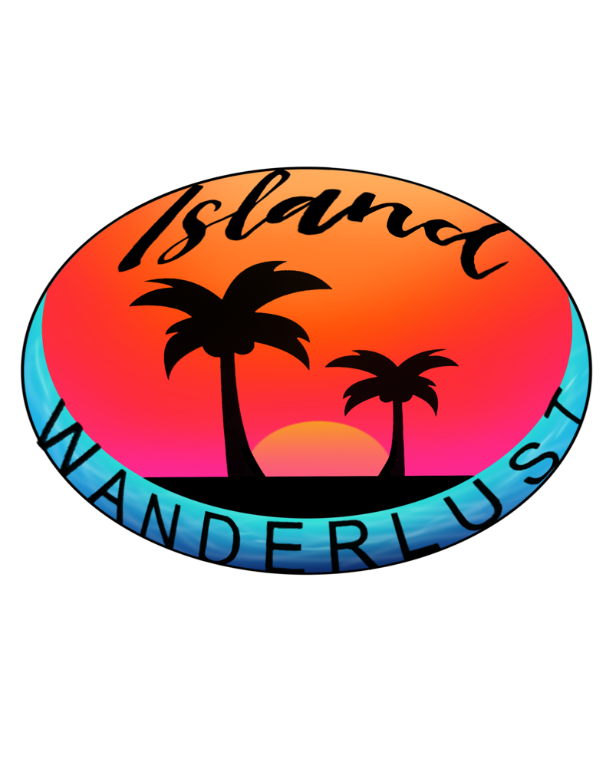

**Island Wanderlust**

Table of Contents

Company Contact Information 3

Email Address 3

Phone Number 3

Instagram Username 3

Company Information 3

Tour Prices 4

Gros Piton Hike 5

Tour Description 5

Saltibus Waterfall 6

Tour Description 6

West Coast Snorkel 7

Tour Description 7

**Company Contact Information:**

**Email Address: IslandWanderlustSLU@gmail.com**

**Phone Number: +1 (758) 758 000**

**Instagram Username: Island_Wanderlust_758**

**Company Information:**

Island Wanderlust is a St. Lucian company that offers exotic tour packages for a reasonable price for adventurous vacationers and locals alike. Do you like scenic views, risky adventures, adrenaline filled endeavors and a thrilling escape from normal life? Then Island Wanderlust can provide you with all of this and more. We are one of the leading tour agencies on the island and we will deliver only the most exclusive experiences that are limited to only our company.

We do not only help you, our customers, to have an exciting adventure but we also employ hundreds of locals aiding the economy. We also partner with many St. Lucian farmers and caterers, instead of those abroad, for the refreshments and meals to be eaten after or before tours, as to keep the tour sites litter free and cleanly. Since we are a local based business we aspire to help our country and its people so that we all may be successful in the future.

A sizable portion of our profits go towards developing the tour sites and the communities they are located in. Because if not for the charming residents in those areas that allowed us to conduct tours in those breathtaking areas our company would not have existed today. So, by investing in community development we are giving back to those hospitable individuals.

Our company is one hundred percent capable of providing you with an exhilarating time and you can trust that we can deliver by just looking at reviews from previous and regular customers. We are known for our extreme safety and precaution when taking care of our customers. While you will have a blast, we will ensure that you shall return completely unharmed from the thrilling tours. So…***Do you dare to come with us to the other side?***

**Tour Prices:**

**Currently Island Wanderlust offers three signature tours as shown in the table below.**

**Prices are listed per person.**

|  |  |  |
| --- | --- | --- |
| **Tour** | **Time** | **Price/**  **EC $** |
| Gros  Piton Hike | 9 a.m.  /  12 P.M. | $50 |
| Saltibus Waterfall | 9 a.m.  /  12 P.M. | $65 |
| West Coast Snorkel | 9 a.m.  /  12 P.M. | $75 |

# **Gros Piton Hike**

**Tour Description:**

One of the great twin peaks of St. Lucia. Half of the well-known local trade mark. The older brother of Petit Piton. Gros Piton is a marvel to behold, standing at 2619 feet it is the second largest mountain on island. It is located in the quiet yet gorgeous tourist epicentre, Soufriere.

Do you want to touch the heavens and feel like you're on top of the world? Then take a guided hike to the summit of Gros Piton where you will see the Island of St. Lucia in its purest most glorious form. The views can only be described as a robber of your breath. Literally and figuratively.

The hike is definitely a rigorous and challenging feat to accomplish. However, with aid from our caring and cautious tour guides, getting to the top is possible and you will conquer this untouched and untamed beast of a trail. You will be left feeling powerful and that you can accomplish anything. Because in truth you can do anything you put your mind to.

Our guides will be available for tours at either 9 am or 12 pm and it will cost EC $50 per person. The hike will take approximately 4 hours in total, 2 hours to travel to the summit and another 2 hours to return.

So, let us take you to the gates of heaven through this titillating experience. You will **not** be the same afterwards.

# **Saltibus Waterfall**

**Tour Description:**

This picturesque waterfall is a hidden gem of the district of Choiseul as it is tucked away in the rainforest. It is only accessible by taking a scenic, hour-long hike through a lush mountainous forest, during which customers are advised to observe the local fauna. The sweet songs of the birds in the forest tops creates a dulcet cacophony that will surely put your mind at ease. Compared to the Gros Piton Hike this one is much easier, although it has its own challenges.

The 30-foot fall can even be scaled, but only by the most daring of people. As risky as it sounds and looks it is completely safe as the tour guides would assist you if you decide to take on the challenge. And from the top you can appreciate the gorgeous view of the entire area before diving back down into the pristine water below.

When arriving at the waterfall, you will be amazed by its beauty. The area is filled with dense vegetation, wildlife and tropical botany. The cool, refreshing water makes the hike all the more rewarding and you will be able to take a dip in the shallow waters. You will be immediately relaxed by the almost rhythmic flowing of the waterfall as well as the melodic sound of the water rushing down.

Our guides will be available for tours at either 9 am or 12 pm and it will cost EC $65 per person.

So, experience nature up close at its finest and appreciate the beauty of waterfalls. You will surely feel carefree and revitalised after letting the water wash away your worries.

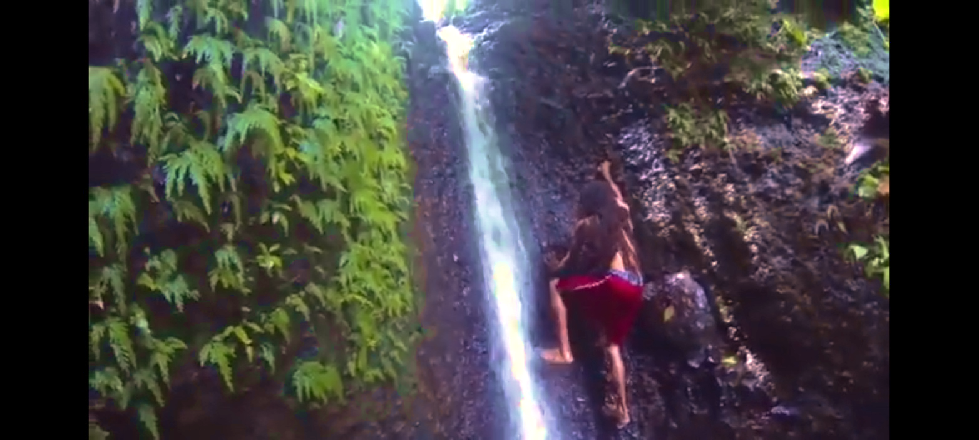

# **West Coast Snorkel**

**Tour Description:**

Are the land tours not to your aquatic tastes? Or perhaps you're looking to get your sea legs? Then look no further than our snorkel tour of the gorgeous Anse Cochon Beach which is located in Anse La Raye, one of the many underwater wonders of the West Coast of the island. The beach itself is only a 5-minute walk away from the main access road.

The salty water is refreshing and chock full of a plethora of aquatic species, including coral, fish, crustaceans and cephalopods. The area is densely populated due to its many boulders and reefs which make for great habitats for the local wildlife. You can find tropical fish such as lionfish, sharp-tail eels, trumpet fish as well as squids and octopi scuttling along the rocky beach floor.

There is also a hidden gem deep beneath the water, the Lesleen M. Wreck, an old cargo ship which sank in 1986. This created a marvelous artificial reef which is home to a number of creatures. On days with high visibility it can be seen resting on the seafloor. However only those brave enough to venture down deep enough would be able to see this sunken beauty.

Our guides will be available for tours at either 9 am or 12 pm and it will cost EC $75 per person.

So, let us take you to the deep end and see the aquatic treasures nature has to offer.

